# Second Research Symposium – 2025 Sri Lanka Institute of Textile and Apparel

**Extended Abstract: Guidelines for Authors**

### An extended abstract should clearly specify theoretical and empirical gaps that the researcher is addressing, a concise review of seminal work, a brief description of the methodology used, results obtained, the expected contributions(s) to theory and practice, and the conclusion resulting from the study.

The elements of your extended abstract can be organized in the following order listed:

* Title
* Author(s) and Affiliations
* Introduction (background, research gap and research questions, originality/ value)
* Objectives
* Methodology
* Results/Findings
* Discussion
* Implications on Research/Policy

## Title/Authors

Include a brief, informative title for the extended abstract. The title should be pre-formatted in the correct style (Initial Caps, 18-pt. Times New Roman boldface, centered). Immediately beneath your title, type the last name with the initials of the author(s) in Times New Roman 12-pt. bold type, left-justified. Below the names of the author(s), state his/her affiliation(s) and complete mailing address(es) in the regular body text in 12-pt font.

## Introduction

The introduction of your extended abstract should state the nature of research gaps you are addressing and why you are studying it. It should provide background information about the work while highlighting other relevant literature and specifying how it relates or differs from your work. You should also discuss the originality/ value of your study in the introduction.

## Body

The body of your extended abstract should follow the introduction and should include methodology, results, discussion, and the directions for future research. The methodology section should be descriptive enough that the reader can identify what was done. References to the methodology are appropriate. The findings and discussion sections may be combined. Within the body of your extended abstract, you can apply as many first-, second-, and third-level headings as you need.

## References

References should be cited within your extended abstract using APA (American Psychological Association) style. For additional information on formatting references, refer to the sixth edition of the publication manual of the American Psychological Association.

## Extended Abstract Length

Extended abstracts should be at least three pages, but not more than four pages in length including the references. The word limit is 1,700 (± 50) words. Authors can change the word count under each sub- sections based on the study but only in the range of the total word count of 1,700 (± 50) [e.g.: one can use 325 for results and 200 for the discussion. However, the final word count cannot be exceeded.]

## Using Predefined Styles

The style elements identified in this section have been defined for you to lend consistency to the group of papers that comprises the conference proceedings. Times New Roman is the preferred font type.

Use the following levels of this font type to describe the different sections of your extended abstract:

1. Title: 18-point Times New Roman Bold
2. Author: 12-Point Times New Roman Bold
3. Heading 1: 14-POINT TIMES NEW ROMAN BOLD, ALL CAPS
4. Heading 2: 14-Point Times New Roman Bold
5. Heading 3: 12-Point Times New Roman Bold
6. Normal: 12-point Times New Roman

## Margins

Use 1-inch margins for top, bottom, left and right margins. Text should be left-justified. All pages should include a page number on the bottom right corner of the page. The number should be in “Normal” font style (12-pt Times New Roman).

#### Line Spacing

Line spacing should be single (0 before and 0 after), except for already predefined styles; leave 1 line space between headings and body text, body text and next heading; and between paragraphs.

## Tables

Tables must be created using the Microsoft Word or WordPerfect table functions and included as part of the text immediately after the first point of reference. DO NOT place them at the end of your extended abstract. For improved readability, keep your tables as simple as possible.

#### Table 1: Table Header

|  |  |  |
| --- | --- | --- |
| **Title 1** | **Title 2** | **Title 3** |

***Source:***

Any explanations of table data should immediately follow the table and be formatted as plain body text. DO NOT include table explanations within tables. Notations and references, such as superscript letters and number notations, are acceptable within the table and a legend describing notations should follow directly beneath the table.

## Figures

Figures include charts, graphs, and drawings. All figures and other graphics should be embedded, or electronically placed, within the text immediately after the first point of reference. DO NOT place them on separate pages at the end of your extended abstract.

#### Figure 1. Figure Header

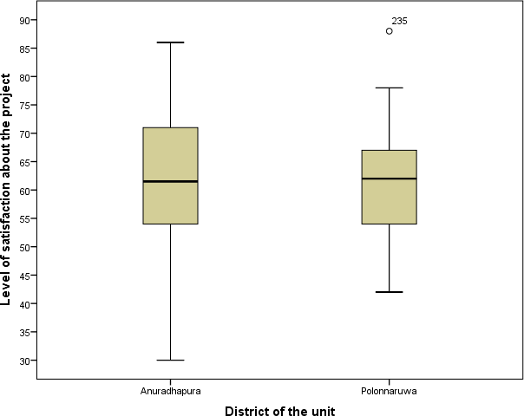

***Source:***

Figures must be labeled properly using Times New Roman 12-pt bold font, with the X and Y axes clearly labeled, and include a legend as appropriate. The figure title should be Times New Roman 12-pt, bold font and appear immediately below the figure (centered).

**Template of the Extended Abstract:**

# Title

*Author Name1 e-mail1*

*Supervisor Name2 e-mail2*

#### INTRODUCTION (max. 225 words)

Provide a clear and impressive introduction to the research. Include a brief of the;

* background
* research problem
* research questions
* Originality/ value

#### OBJECTIVES (max. 100 words)

[Please outline here the objective of the research.]

#### METHODOLOGY (max. 225 words)

[Please outline here the data/methodology of the research.]

#### RESULTS/FINDINGS (max. 350 words)

[Please outline here the results/findings of the research]

#### DISCUSSION (max. 250 words)

[Discussion of the results in the light of literature.]

#### IMPLICATIONS ON RESEARCH/POLICY (max. 150 words)

[Please outline here the implications for the industry/policy.]

***Keywords:*** *keyword 1, keyword 2, keyword 3, keyword 4. (maximum 5 key words)*

#### REFERENCES (max. 400 words)

[Only the literature used in this extended abstract]